Answer 8
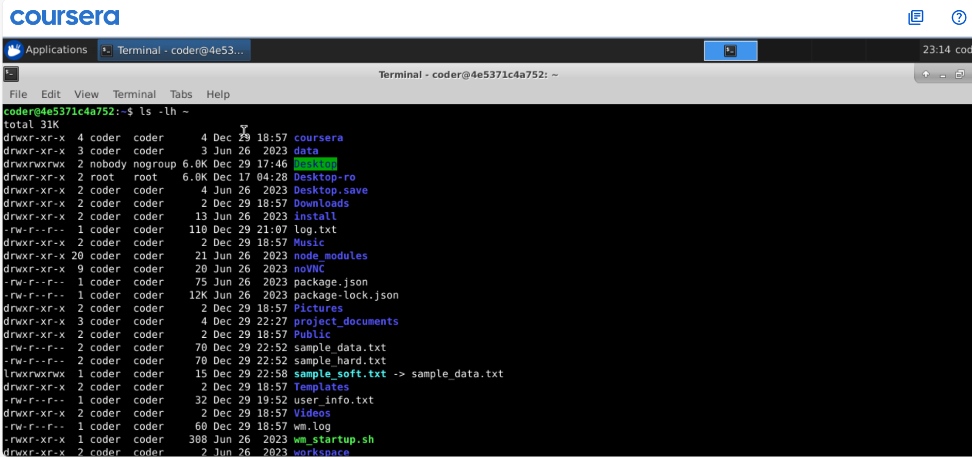
Explanation: using ls command with -lh option will show detailed view with human readable data size. In above some files which are really small or kind of empty shows in bytes as 4 or 2 etc.

